**01. Which three factors should be considered when implementing a Layer 2 protocol in a network? (Choose three.)**

* the geographic scope of the network
* the physical layer implementation
* the number of hosts to be interconnected

**02.**

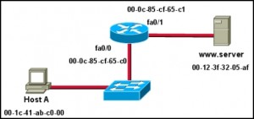**Refer to the exhibit. Assuming that the network in the exhibit is converged meaning the routing tables and ARP tables are complete, which MAC address will Host A place in the destination address field of Ethernet frames destined for www.server?**

* 00-0c-85-cf-65-c0

**03. Which options are properties of contention-based media access for a shared media? (Choose three.)**

* non-deterministic
* less overhead
* collisions exist

**04. What is true concerning physical and logical topologies?**

* Logical topologies consist of virtual connections between nodes.

**05. What determines the method of media access control? (Choose two.)**

* media sharing
* logical topology

**06. What is true regarding media access control? (Choose three.)**

* Ethernet utilizes CSMA/CD
* defined as placement of data frames on the media
* Data Link layer protocols define the rules for access to different media

**07. Which statements describe the logical token-passing topology? (Choose two.)**

* Computers are allowed to transmit data only when they possess a token.
* Electronic tokens are passed sequentially to each other.

**08. A network administrator has been asked to provide a graphic representation of exactly where the company network wiring and equipment are located in the building. What is this type of drawing?**

* physical topology

**09. What is the purpose of the preamble in an Ethernet frame?**

* is used for timing synchronization

**10. What statements are true regarding addresses found at each layer of the OSI model? (Choose two.)**

* Layer 2 may identify devices by a physical address burned into the network card
* Layer 3 represents a hierarchical addressing scheme

**11.**

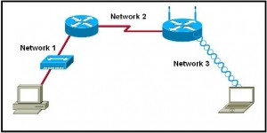**Refer to the exhibit. Which statement describes the media access control methods that are used by the networks in the exhibit?**

* Network 1 uses CSMA/CD and Network 3 uses CSMA/CA.

**12.**

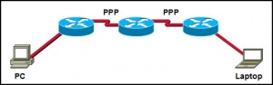**Refer to the exhibit. How many CRC calculations will take place as traffic routes from the PC to the laptop?**

* 8

**13.**

**Refer to the exhibit. A frame is being sent from the PC to the laptop. Which source MAC and IP addresses will be included in the frame as it leaves RouterB? (Choose two.)**

* source MAC – Fa0/1 on RouterB
* source IP – PC

**14. Which sublayer of the data link layer prepares a signal to be transmitted at the physical layer?**

* MAC

**15. What two facts are true when a device is moved from one network or subnet to another? (Choose two.)**

* The device will still operate at the same Layer 2 address.
* The Layer 3 address must be reassigned to allow communications to the new network.

**16. What is a function of the data link layer?**

* provides for the exchange data over a common local media

**17. What is a characteristic of a logical point-to-point topology?**

* The media access control protocol can be very simple.

**18. What is a primary purpose of encapsulating packets into frames?**

* facilitate the entry and exit of data on media

**19. What is the primary purpose of the trailer in a data link layer frame?**

* support frame error detection

**20. What are three characteristics of valid Ethernet Layer 2 addresses? (Choose three.)**

* They are 48 binary bits in length.
* They are considered physical addresses.
* They are generally represented in hexadecimal format.